|  |  |  |  |  |  |
| --- | --- | --- | --- | --- | --- |
| **Module No:** | 1 | **IU No:** | 1 | **Exercise No.** | 1 |

**Name : Ida Bagus Ketut Yoghantara**

|  |  |
| --- | --- |
| **Lab Assessment Statement** | **Assignment 1 - Build an API**  **Project Scenario,**  The scope of this assignment is to develop an API for ‘XYZ Cars Pte Ltd’ as a website developer to develop a Used Car Sales portal.  In this assignment, Users will be able to register in the portal using the Registration Page. Users of the portal can search for Cars using Make, Model, Registration & Price Range. Users will be able to view the Car information after searching them. The portal allow users to login, post Car for sale.  These are the steps provided to build an API.   1. Create SpringBoot application [Spring Initializr](https://start.spring.io/). Import the project in your IDE. 2. Create entities for your backend as per the scenario. 3. Create Repositories using JPA repositories. 4. Create service layer to access the data in your API 5. Create controller for your application using REST API 6. Test your API using POSTMAN tool.   **Provide the source code of developed application.**  **Provide screen capture of final result pages for API testing.** |
| **Technical Environment** | -JAVA, JPA, REST API |
| **Guidelines** | - |
| **Duration** | 120 mins |

1. Create SpringBoot application [Spring Initializr](https://start.spring.io/). Import the project in your IDE.

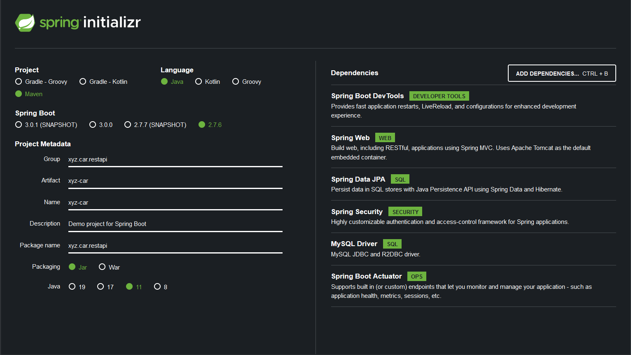

1. Create entities for your backend as per the scenario.

**UserAccount**

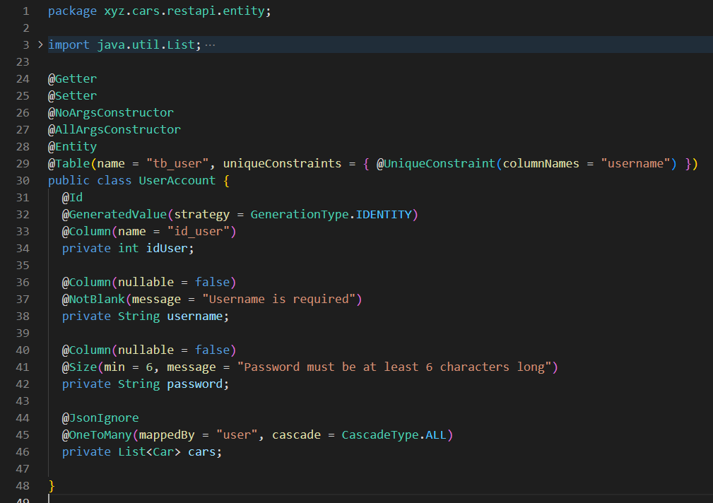

**Car**

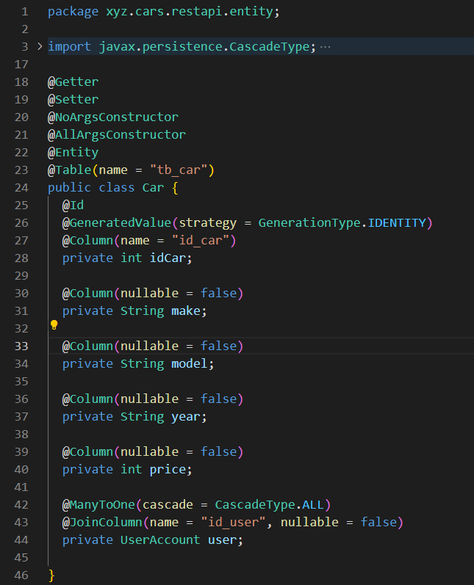

**CarDto**

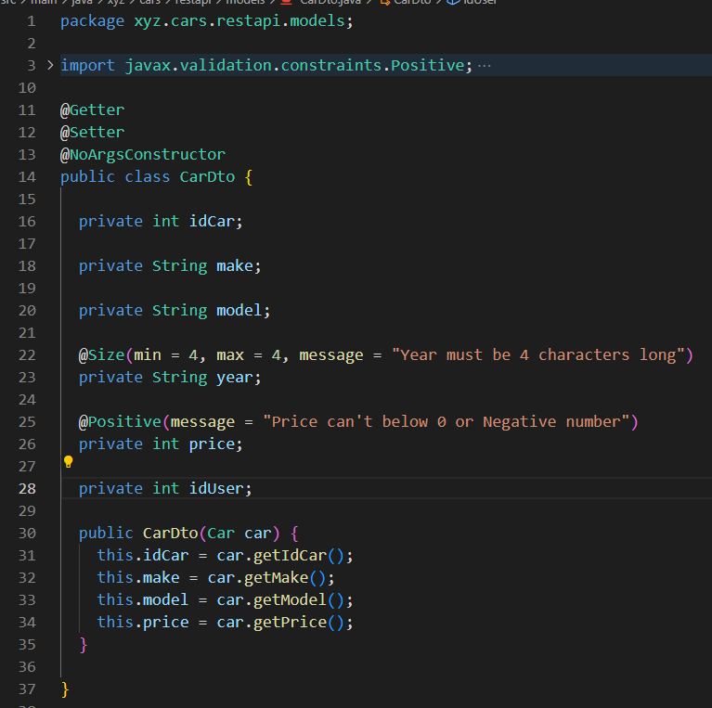

1. Create Repositories using JPA repositories.

**UserRepository**

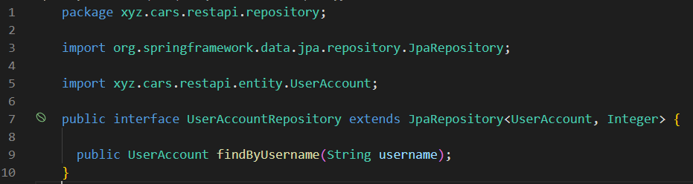

**CarRepository**

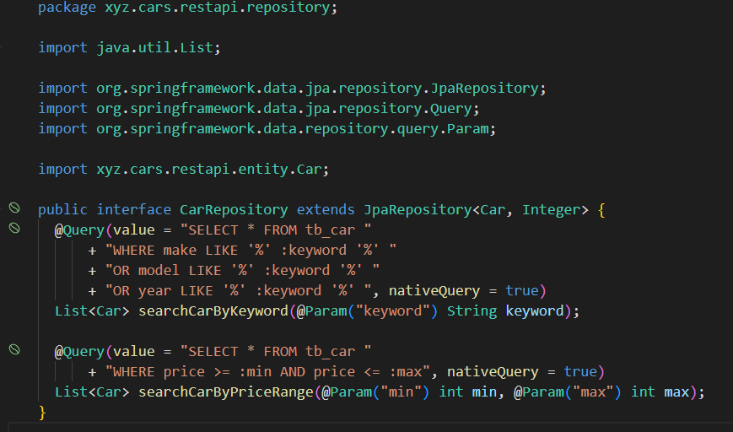

1. Create service layer to access the data in your API

**CarService**

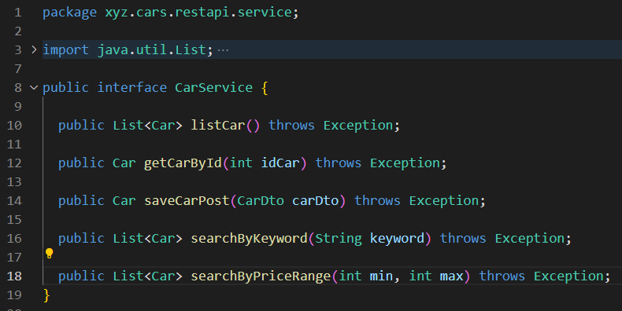

**CarServiceImpl**

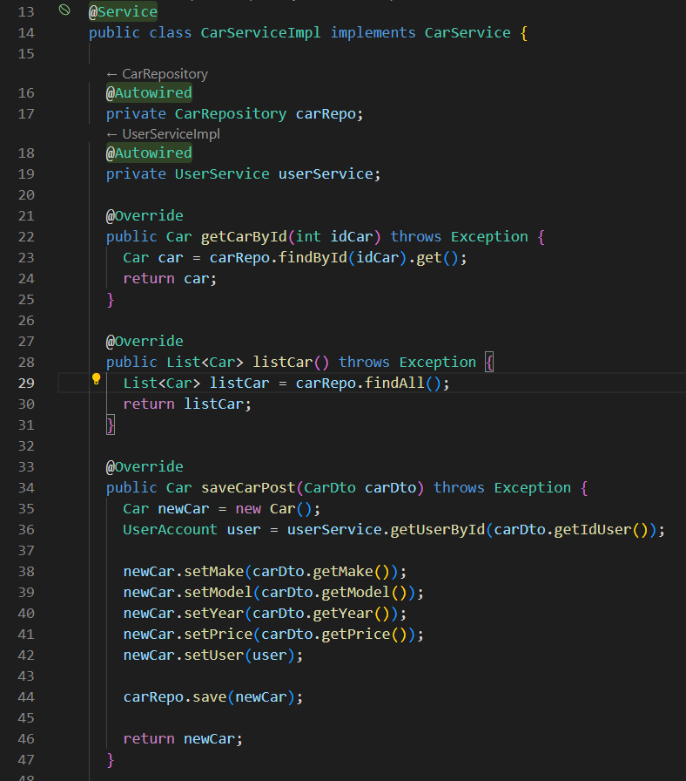

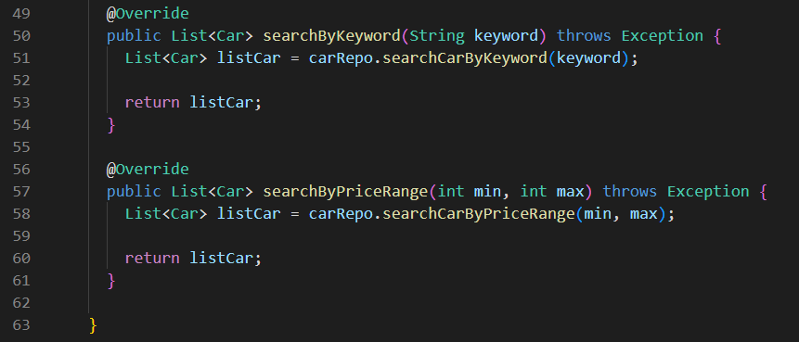

**UserService**

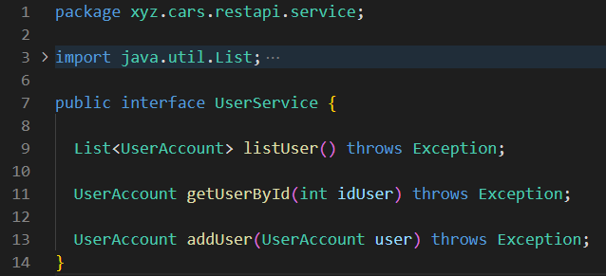

**UserServiceImpl**

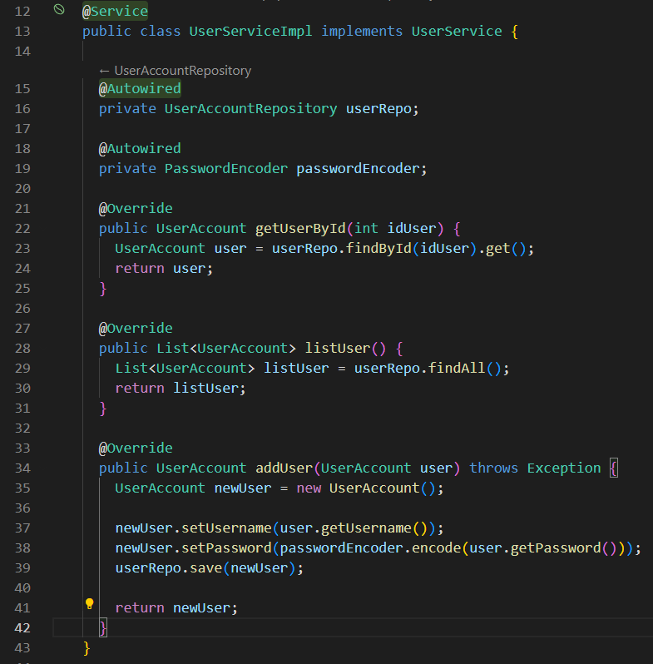

1. Create controller for your application using REST API

**CarController**

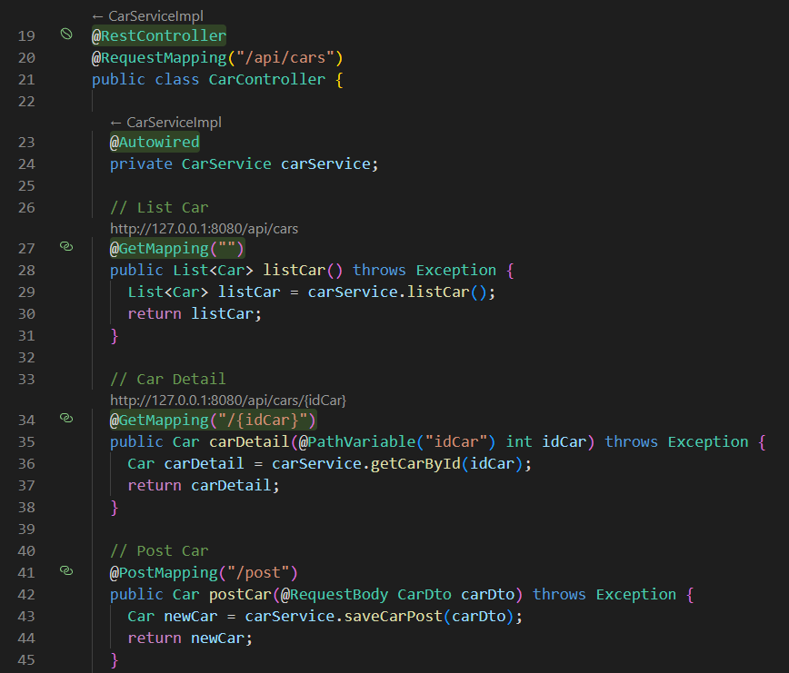

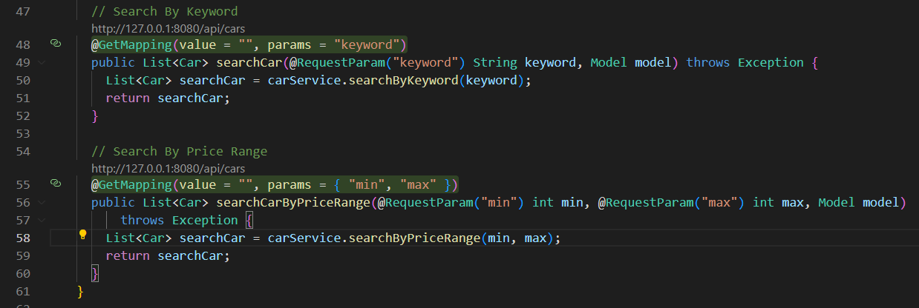

**UserController**

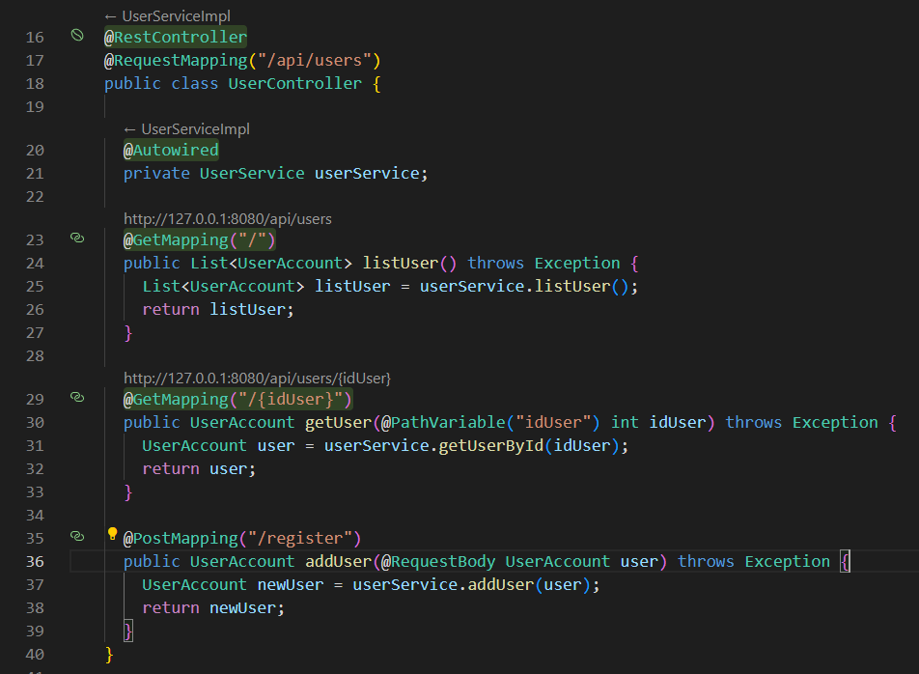

1. Test your API using POSTMAN tool.

**Register**

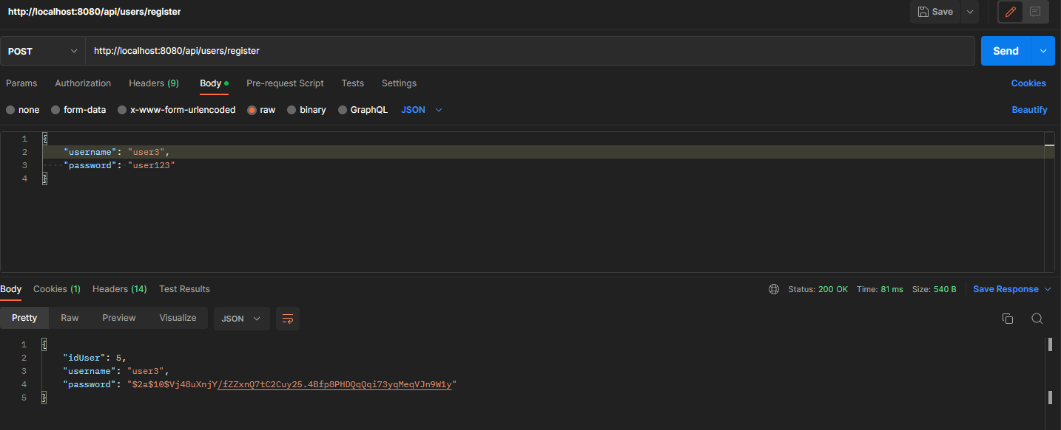

**Car List**

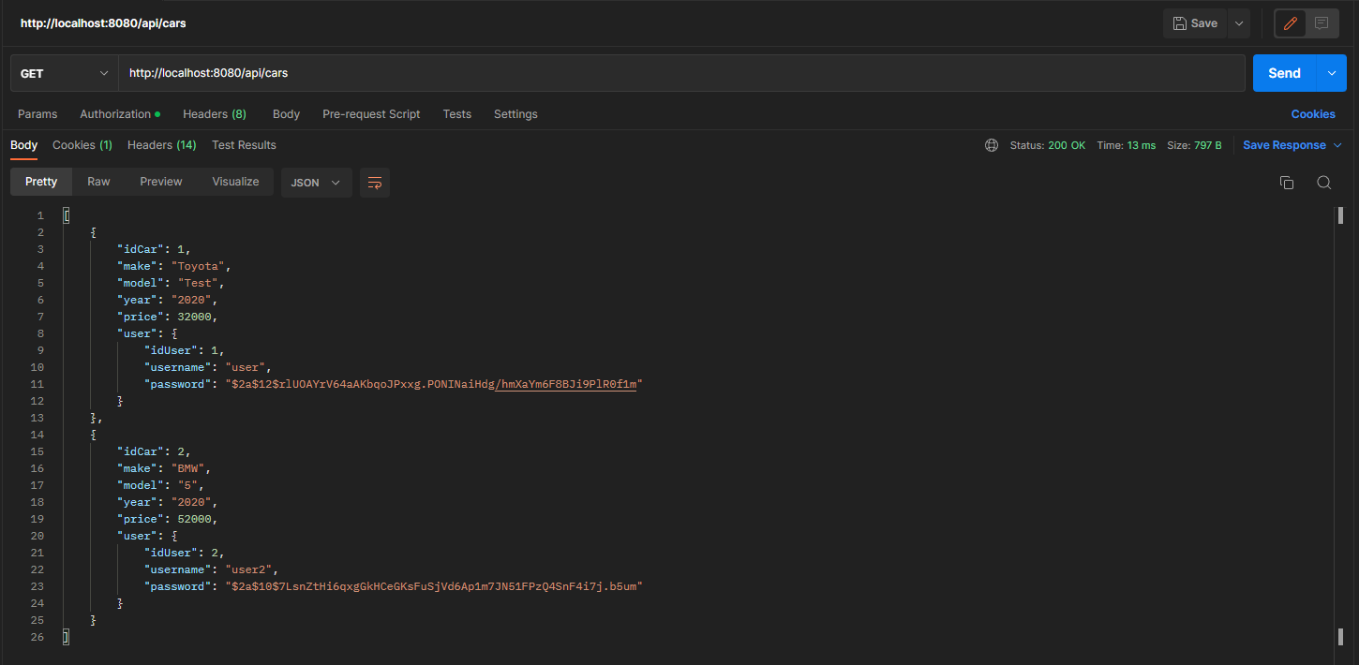

**Car Detail**

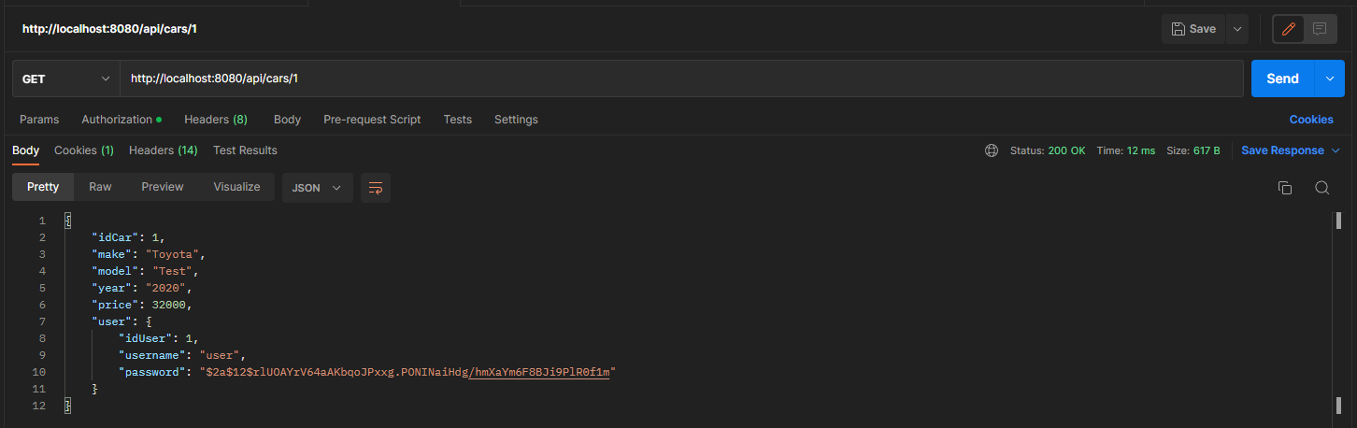

**Post Car**

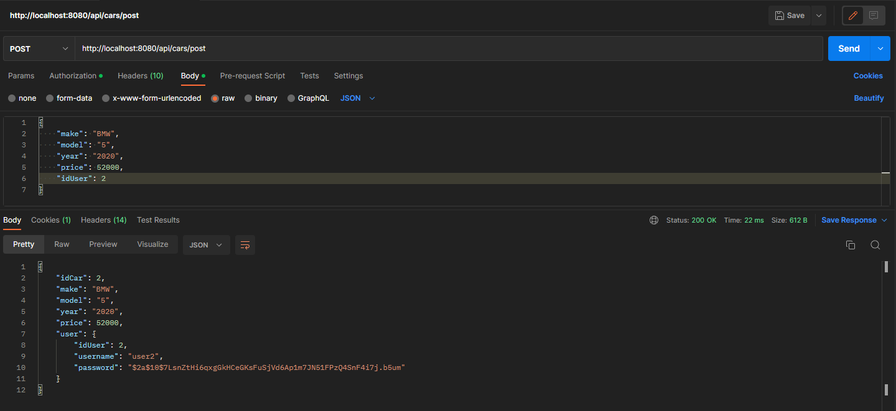

**Search Car by Keyword (Make, Model, Year)**

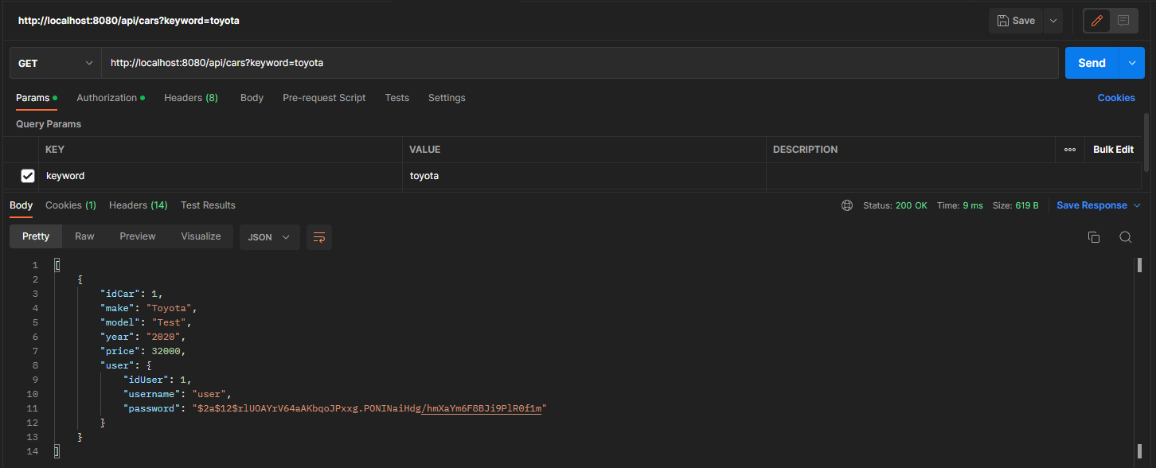

**Search Car by Price Range (minimum, maximum)**

